The Mental Health Consequences Before and After George Floyd’s Murder in Minneapolis in Black, Latine, and White Communities

Abstract

The high-profile police murder of George Floyd is likely to have an aftermath of negative health consequences, particularly among Black people. Our study evaluates the impact of the murder of Mr. Floyd on mental health in Black, Latine, and white communities in Minneapolis, Minnesota. We constructed a panel dataset merging data from the Minnesota Hospital Association, Minnesota Department of Natural Resources, Minneapolis Police Department, and American Community Survey. First, we specify an overall and racial subgroup autoregressive interrupted time-series design to identify the impact of the murder on rates of mental health hospital discharge at the city-level. We then examine the spatial heterogeneity in the effect of the murder by specifying zip code tabulation area (ZCTA)-level panel models. We find a 0.23 per 1,000 increase in mental health conditions among Black people in the immediate post-murder period, followed by a weekly decline (-.007) in mental health diagnoses. We do not find a substantial rate increase in White or Latine residents. Further, our analyses at the ZCTA-week-level corroborate these findings, while showing that the increase for Black residents was *global*. These findings speak to the traumatizing effects of police violence and the short- and longer-term public health consequences for Black communities.

The Mental Health Consequences Before and After George Floyd’s Murder in Minneapolis in Black, Latine, and White Communities

**Introduction**

Racialized police violence has been pervasive throughout United States history. As James Baldwin noted, “History is not something you read about in a book; history is not even the past, it’s the present, because everybody operates, whether or not we know it, out of assumptions which are produced only, and only by our history.”[1](https://www.zotero.org/google-docs/?c3U3hA) America’s history of slave patrols is reflected in the police violence against Black people today.[2](https://www.zotero.org/google-docs/?YVlBee) Black people are 5 times more likely than white people to sustain an injury during a police encounter that requires emergency room care[3](https://www.zotero.org/google-docs/?QTInbs), and are disproportionately subject to police uses of force[4](https://www.zotero.org/google-docs/?YyLvMa) and face substantially higher lifetime risks of being killed by police.[5](https://www.zotero.org/google-docs/?sidiei) A large proportion of police violence is targeted against Black people, however, individuals with other marginalized identities (ex. other racial/ethnic groups, sex workers, or transgender people) are impacted disproportionally as well. People of color make-up approximately 40% of the US population but account for more than half of the years of life lost due to police violence. [6(pp2015–2016),7](https://www.zotero.org/google-docs/?DjOmSG)

Police violence is deleterious to individual mental health. Direct exposure to police violence increases individuals’ reports of general anxiety, depression, trauma symptoms, suicide attempts, and anticipation of future police violence victimization.[8–10](https://www.zotero.org/google-docs/?HL0TLm) However, the health effects of police violence extend beyond individual injury to influence population health outcomes. Vicarious exposure to police violence, such as witnessing or hearing about a police violence event is associated with increased anxiety, depression, trauma symptoms, and suicide attempts. For instance, one study of a population representative sample of Black people found that an exposure to a police killing of an unarmed Black person was associated with .14 additional poor mental health days per month.[11](https://www.zotero.org/google-docs/?B4cX5X) However, there were no mental health impacts among white individuals.[11](https://www.zotero.org/google-docs/?Z1Qtqr) The full physical and mental trauma caused by police is unknown due to poorly documented or comprehensively collected data.[6(pp2015–2016)](https://www.zotero.org/google-docs/?UOSHWF) Further the lack of fine-grained spatial and temporal data limits the ability for more sensitive analyses expanding beyond the current body of literature which is made up of predominantly descriptive or cross-sectional studies conducted at the state-level and above.

The murder of Mr. George Floyd brought mainstream visibility to the health burden of police violence predominantly borne by racialized marginalized communities.[12](https://www.zotero.org/google-docs/?7PsYb4) An approximately ten minute long video by Ms. Darnella Frazier of this murder was posted on Facebook and watched by millions of people. The video and story were subsequently replayed on news outlets and across social media platforms, potentially further traumatizing marginalized communities. Research shows in the week following the murder of Mr. Floyd, there was an unprecedented nationwide increase -- above existing COVID-19 pandemic highs -- in reports of anger and sadness.[13](https://www.zotero.org/google-docs/?3e7EGX) Reports of anxiety and depression also increased during this time, especially among Black Americans. Geographic proximity also shapes responses to police violence. Minnesota reported the largest decline in mental health compared to other states, and Black people living in Minnesota likely experienced the most substantial mental health effects after Mr. Floyd’s murder.[13](https://www.zotero.org/google-docs/?zgJLkT) This reaction to a highly visible example of police violence is consistent with findings from a recent nationally-representative study that found most Black people live in fear of the police killing them or their family members.[14](https://www.zotero.org/google-docs/?3YUKqQ) However, most of the research conducted to date has been based on cross-sectional studies, self reported measures, and limited consideration of geography.[15,16](https://www.zotero.org/google-docs/?TiDXJm)

In order to fill these gaps, our study seeks to evaluate the rate of mental health (anxiety, depression, and chemical health) diagnoses over time and space after the murder of Mr. Floyd on May 25th, 2020 in communities in Minneapolis, Minnesota. We contribute to the existing literature by a) utilizing five years of time series and panel data to examine changes in response to the police murder, b) using an alternative measure of mental health diagnosis as opposed to self reports, and c) examine the hyperlocal effects, and spatial heterogeneity therein, of the murder across Minneapolis, MN.

**Methods**

***Data***

We leverage Minnesota Hospital Discharge data from the Minnesota Hospital Administration (MHA) to create our dependent variable, mental health hospital diagnoses per 1,000 residents. All Minnesota hospitals submit inpatient, outpatient, and emergency department claims data to the MHA. The MHA collects these data into a statewide administrative claims database. This database includes a data point for each patient encounter with a health care provider, the diagnosis/es during that encounter specified with International Classification of Diseases (ICD) codes, as well as basic demographic information, such as age, gender, and race. Hospital discharge data has the advantage of being population representative. Data from 2016-2020 utilizing ICD-10 were used to define mental health diagnoses.[17](https://www.zotero.org/google-docs/?DlTPwa) We also calculate race-specific measures of mental health diagnoses incidence per 1,000 residents. In our interrupted time-series design (discussed below), the key time indicators are a baseline weekly linear trend (*T*), an exposure indicator of the police murder of George Floyd on 5/25/2020 (*Post-Killing*), and a linear time trend post-killing (*T Post-Killing*). The weekly time trend captures the overall linear trend in mental health discharges across 2016-2020, the binary exposure variable indicates the discontinuous change in the week of the police murder of George Floyd, and the post-killing term describes the linear trend in mental health discharges after the murder.

In addition to our focal time measures, we further improve our identification of the post-killing effect in our interrupted time series design by controlling for *time-varying* changes in COVID-19-related policy, police behavior and seasonality. We create two event indicators related to the COVID-19 pandemic: 3/13/2020 at the inception of Governor Walz’s State of Emergency order, and from 3/28-2020-5/28/2020 at the introduction and conclusion of Minnesota’s Stay-at-Home order. These time indicators adjust for changes in mental health discharges related to significant policy events in the course of the COVID-19 pandemic and related patterns of social interaction and movement. We also incorporate measures of police behavior from the Minneapolis Police Department’s open access data. Specifically, we aggregate and spatially locate reported use of force incidents, police stops, and officer-involved shootings to both the week and ZCTA-week level from 2016-2020, placing each incident in each ZCTA-week by the date of incident and the spatial intersection of each ZCTA and the longitude and latitude coordinates of the location of the recorded police event. We then express these measures as rates per 1,000 residents. Further, we lag each measure of police behavior by one week to account for the potential simultaneity between police behavior and mental health incidence. These measures serve as our indicators of policing activity in Minneapolis, and will adjust our event coefficients for any concurrent changes in police stops, uses of force, or shootings. In other words, these measures allow us to further isolate the effect of the focal police killing, *above and beyond* changes in routine police behavior.

Previous research shows that mental health discharges exhibit a seasonal pattern (e.g., Heboyan et al. 2019), and we merge measures of seasonality onto the weekly hospital data. To capture weekly changes in seasonality, we include the weekly maximum temperature (degrees Fahrenheit), snowfall (in.), and precipitation (in.) from the Minnesota Department of Natural Resources as measured at the Minneapolis/St. Paul Threaded Record station.

Spatial Zip Code Tabulation Area (ZCTA) simple feature boundary attributes, and each geography’s corresponding yearly American Community Survey (ACS) data, were accessed from The Census Bureau’s API using the ‘tidycensus’ package in R.[18](https://www.zotero.org/google-docs/?zAaHUE) ZCTAs representing Minneapolis were determined by spatial intersection with the Minneapolis city boundary. Additionally, intersecting neighbors were defined as >= 5 percent spatial overlap to identify ZCTAs that contain enough spatial overlap to have records in the Minneapolis Police Department data. Similar to previous research on neighborhood effects,[19,20](https://www.zotero.org/google-docs/?jla45X) we create a construct of concentrated disadvantage using time-varying indicators from the ACS 5-year estimates using five indicators: the unemployment rate, percent below the poverty line, the percent of female headed-households, the percentage of the population with no high school diploma, and the population of Black residents. We construct this measure using a confirmatory factor analysis to explicitly account for measurement error in this construct (see *Appendix* for model specification). This measure serves as our proxy for structural racism and disadvantage in our tests of spatial heterogeneity below.

***Statistical Method***

We first construct time-series plots of mental health diagnoses incidence over the period from 2016-2020. Figure 1 displays the overall time trend in mental health diagnoses per 1,000 across Minneapolis, and Figure 2 displays the time series by racial subgroup. We then estimate autoregressive interrupted time-series models on week-level data in Minneapolis. Interrupted time series designs compare the levels of outcomes after a treatment or intervention to the mean outcome level in the pre-intervention period. The pre-treatment trend is assumed to serve as the counterfactual should treatment not have occurred (i.e. the trend in mental health discharges in the counterfactual scenario where the police killing of Mr. Floyd did not occur). The design exclusively uses *within-unit* over time variation, so time-stable confounders are uncorrelated with the time-varying treatment. However, the design is susceptible to time-varying confounders, which can vary alongside treatment timing, and we therefore include a suite of time-varying controls to strengthen our causal identification in the ITS design. Further, the design is susceptible to temporal autocorrelation in the series, and therefore we include temporal autoregressive lags of mental health discharges in the *t-lag* week to adjust for the impact of previous mental health diagnoses on contemporaneous diagnoses, effectively controlling for the possibility of the focal event timing being confounded with recent changes in mental health diagnoses.[1] In sum, our causal identification assumes that the police-killing, and its consequences, are the only exposures that change at the time of the event, net of the observed time-varying covariates. Thus, we specify the following model



where 𝜃 represents the focal parameter of interest: the change in the time series of mental health discharge rates in response to the police killing. We specify models for Minneapolis overall as well as subgroup models for White, Black, and Latine residents, and the results of each are presented in Table 1.

We subsequently estimate random coefficient interrupted time series panel models for the White, Black, and Latine racial subgroups with random ZCTA intercepts and ZCTA random *Event* coefficients on Zip Code Tabulation Area (ZCTA)-week level data. This ITS specification using the panel data allows the intercept and focal *Event* coefficients to vary by ZCTA allowing us to a) estimate the effect of the police killing *within* each ZCTA and account for baseline ZCTA differences in mental health (random intercept), as well as b) examine the *spatial heterogeneity* in the post-killing effect (random coefficient) for each racial subgroup. The RE panel model for each subgroup is specified as follows:

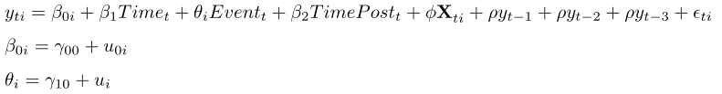

where 𝜃i represents the estimated post-killing increase in each ZCTA respectfully. Further, we specify the random effects models to have correlated random effects, which allow that the random intercepts and slopes may be related in some manner. These RE panel specifications include the full suite of controls for time-varying seasonality, police behavior, and COVID-19 policy, as well as three lagged AR terms to control for autocorrelation structure in the data.

We also estimate a random coefficient models for each racial subgroup with a cross-level interaction between the post-killing indicator and concentrated disadvantage to examine the spatial heterogeneity in the post-killing effect across communities, and to assess the moderating influence of structural racism and disadvantage on the effect of the police killing. In other words, we explicitly test the extent to which the post-killing increase was *different* in areas of higher concentrated disadvantage and to what extent concentrated disadvantage may explain any Post-Killing effect heterogeneity. Finally, we construct choropleth maps of both the estimated random coefficients from the base random coefficient models and latent concentrated disadvantage measure by ZCTA to visually contextualize the spatial heterogeneity of the post-killing effect across Minneapolis. Due to the increasing concern about null hypothesis significance testing,[21](https://www.zotero.org/google-docs/?k9Ws4L) this paper focuses on estimation of associations and the broad pattern of results as opposed to significance testing. All data and code for data manipulation, merging, and analysis, apart from the restricted MHA data, are available in an online GitHub repository.

**Results**

***Temporal Pattern of Mental Health Diagnoses***

Figure 1 displays the weekly incidence of mental health hospital diagnoses in Minneapolis from 2016-2020. The series exhibits a fairly consistent pattern in the pre-treatment period, followed by a decline in the weeks preceding the COVID-19 pandemic, alongside a modest increase in mental health diagnoses post-killing. In the month pre-killing we observe a rate of mental health diagnoses overall of about 1.85/1,000, as compared to a rate of 1.93/1,000 post-killing a modest overall increase of .08/1,000. After this initial modest increase of ~4%, the rate modestly declined to levels roughly commensurate with the month pre-killing.

[FIGURE 1 HERE]

Figure 2 relays the racial group-specific time series of mental health hospital diagnoses. The beginning of the series exhibits fairly similar mental health rates across racial groups, with a divergence happening in 2017 between the rate for Black residents as compared to White and Latine residents. While both the White and Latine time series do not visually appear to have large increases post-killing, with differences of .02 and -.03 in the month prior compared to the month post-killing for each group respectively. However, the discontinuity in the Black time series is substantially larger, with a post-killing rate of 1.15/1,000 as compared to a weekly rate of 1.02 in the month pre-killing (a 12.7% increase).

[FIGURE 2 HERE]

***Autoregressive Interrupted Time Series Models***

Table 1 presents AR(3) interrupted time series models of the mental health diagnosis rate in Minneapolis from 2016-2020. Model 1 regresses the overall mental health diagnosis rate per 1,000 on the time measures (discussed above) as well as the time-varying controls for seasonality, police behavior, and COVID-19 related policy. The model also adjusts the estimates for temporal autocorrelation with three lagged AR terms, effectively netting out the impact of previous mental health diagnoses on future discharges. Our focal parameter estimate of interest, *Post-Killing*, represents an instantaneous increase of .152 mental health discharges per 1,000, followed by weekly linear average declines of .01 per week. Effectively, this means that it took ~15 weeks for the post-killing effect to dissipate to comparable pre-treatment levels.

[TABLE 1 HERE]

The racial subgroup models highlight the racial heterogeneity in the effect of police-killing on mental health diagnoses. Models 2 and 4, models for the White and Latine mental health discharges respectfully, show a weak increase post-killing, with increases of .061 and .022 respectively. In contrast, Model 2, which models the Black mental health diagnosis rate, exhibits a quite large increase of .228 mental health diagnoses per 1,000 Black residents in post-killing. Further, this post-killing increase has some longevity: our estimates suggest that the Black mental health diagnosis rate has not returned to pre-treatment levels. At a weak weekly decrease of .007 mental health discharges per 1,000, the model estimates that it took ~32.6 weeks for discharge rates to return to pre-treatment levels (although this extrapolates beyond the observed series, as the decreases could have “sped up” in the early part of 2021). This suggests that the post-killing effect was driven primarily by increases in Black mental health discharges, and suggests that the police murder of George Floyd had a disproportionate, and substantially lengthy, negative impact on the Black community in Minneapolis in terms of hospitalized cases of mental health as compared to the other racial subgroups.

Table 2 presents the White and Black race-subgroup ITS Random Coefficient models, which use the within-neighborhood variation to estimate the *Post-Killing* effect and allow for both the model intercept (i.e., the baseline level of mental health discharges, and *Post-Killing* coefficients to vary by ZCTA. Corroborating the results of the pooled Minneapolis ITS models (see Table 1), within-neighborhood comparisons show post-killing decrease of .002 for white residents, indicating that hospital mental health diagnoses for White residents did not appreciably change on average in the wake of the police killing. In contrast, Model 2 indicates a substantial increase in Black residents' mental health hospital diagnoses post-killing, with an increase of 2.9 per 1,000 Black residents. This substantiates at the neighborhood-level the racially bifurcated effect of the police murder of Mr. Floyd in Minneapolis, MN. The Latine model (Model 3) indicates a modest reduction in mental health diagnoses post-killing, although the 95% confidence intervals indicate a wide variance in this estimate and the interval includes 0. Models 4, 5, and 6 add the aforementioned interaction term between the post-killing term and concentrated disadvantage to each racial subgroup RE model. The interaction term in Model 4 indicates that the post-killing effect for White residents exhibited heterogeneity by disadvantage, with a one standard deviation increase in concentrated disadvantage leading to a .19 greater post-killing increase in White residents’ mental health diagnoses. Similarly, Model 6 exhibits a positive interaction term wherein the slight decreases in Latine residents’ mental health diagnoses post-killing were smaller in areas of higher disadvantage (although the 95% CI for this estimate includes 0). In contrast, Model 5 shows that, while still positive in magnitude, the interaction term is much smaller in magnitude comparatively (and the 95% CI for this estimate includes 0), suggesting that the post-killing increases did not vary appreciably by the level of concentrated disadvantage for Black residents to the same extent as they did for White residents. In sum, these models illustrate that the deleterious impacts of the police killing 1) was concentrated amongst Black mental health, 2) was observed *city-wide,* and 3) negative mental health effects for Whites were spatially located in areas characterized by high levels of concentrated disadvantage.

[TABLE 2 HERE]

Figures 3, 4, 5, and 6 contextualize these patterns by plotting the spatial distribution of post-killing random coefficients from the base RE models for White (Figure 3), Black (Figure 4), and Latine (Figure 5) residents alongside levels of concentrated disadvantage (Figure 6). In general, the White and Latine post-killing effects tend to be stronger (or less negative in the case of Latine residents) in areas of higher concentrated disadvantage, such as North Minneapolis and the East Phillips neighborhood (the red and orange areas of Figure 6).[2] In contrast, the post-killing increases in Black mental health discharges were remarkably stable across space, with the exception a slight decrease in downtown Minneapolis, and a quite large increase in mental health diagnosis rates for Black residents in ZCTA 55455, which is the ZCTA that contains the University of Minnesota-Twin Cities campus. Note also the magnitude and scale of the estimated effects shown in Figure 4 relative to the more modest effects in Figures 3 and 5. In general, these patterns of results establish the *spatially racialized* character of the harmful effects of police violence, where Black residents experience a universal harm and the negative effects for White residents are confined to those disadvantaged.

**Discussion**

In the wake of George Floyd’s murder, our study found a modest overall increase of mental health diagnoses followed by a decline to levels approximating those observed in the pre-murder period. However, our racially-stratified analysis finds much larger deleterious impacts of the police murder among Black residents. Specifically, we find that they experienced a universal (spatially) and longstanding harm whereas there was little impact for Latine and white residents, but the harmful effects for these groups were spatially located in areas characterized by high levels of concentrated disadvantage.

Our results suggest that residing in advantaged neighborhoods did not insulate Black people from experiencing mental health diagnoses post-murder of Mr. Floyd. The global effects of Mr. Floyd’s murder on Black people’s mental health are likely reflective of structural racism, which Bailey et al. define as “the totality of ways in which societies foster racial discrimination through mutually reinforcing systems of housing, education, employment, earnings, benefits, credit, media, health care, and criminal justice.”[22](https://www.zotero.org/google-docs/?zwUMLs) Structural racism is a fundamental cause of health inequity that undermines health through a series of interdependent pathways, including (but not limited to) economic injustice and social deprivation, inadequate health care, maladaptive coping mechanisms, and psychosocial trauma.[22,23](https://www.zotero.org/google-docs/?LFGlq3) Our work adds further evidence that police violence operates as a fundamental mechanism in the structural racism-health pathway that (re)produces, in part, the racial disparities in health we observe. These structural racism-health pathways create, in part, racial disparities in police contact and downstream disparities in mental health concerns. Economic injustice and social deprivation increase the chances that Black neighborhoods experience high concentrations of community and police violence.[24](https://www.zotero.org/google-docs/?OawuGp) As such, vicarious police violence exposures may exacerbate symptoms of untreated psychological distress and foster psychosocial trauma. Black people in-and-out-of-advantaged contexts can experience this psychosocial trauma; each high profile police murder of an unarmed Black person adds another racial injustice to the nation’s legacy of limited accountability for anti-Black violence.[25](https://www.zotero.org/google-docs/?mbYG4Q) The resulting racial trauma manifests itself in the increased worry, anticipatory stress, and adverse mental health that we found in our analysis.[14](https://www.zotero.org/google-docs/?XUfBjU)

Our study is not without limitations. First, hospital discharge data only captures mental health diagnoses among those who went to the hospital for care, ie. more serious cases. Mental health stigma, a lack of health insurance, or medical mistrust, which is fostered by police violence exposure, could serve as barriers to seeking hospital care.[26](https://www.zotero.org/google-docs/?3wV5fV) This self-selection of not receiving health care could have also been exacerbated because of COVID-19. Second, despite our efforts to adjust estimates for changes in COVID-19-related policy, police behavior and seasonality, we cannot rule out other unmeasured confounders that could represent a threat to internal validity. Our identification strategy in the ITS model assumes that the event shift in mental health diagnoses is fully attributable to the event. However, if other changes contemporaneous with the event week took place (e.g., changes in population composition, other exogenous events), net of our time varying controls, our estimates would be biased. Third, although our models focus on Black, white, and Latine residents, our analysis does not examine effects among Indigenous residents, who have been historic targets of police violence in Minneapolis[27](https://www.zotero.org/google-docs/?Z0nGe1) and elsewhere.[5](https://www.zotero.org/google-docs/?c6VSG7) This historical trauma could have also worsened this group's mental health due to the murder of Mr. Floyd. However, due to sparse data in this subpopulation we were not able to explore this.

In conclusion, these findings speak to the traumatizing effects of police violence and the short- and longer-term public health consequences for communities, particularly Black communities. We have much historical and contemporary evidence that Black residents are disproportionately the targets of police violence. Our study adds to the mounting evidence showing the disproportionate mental health consequences of this violence.

**References**

[1. James Baldwin’s National Press Club Speech. *National Press Club*. Published online 1986. Accessed April 13, 2023. https://www.press.org/author-speech-0](https://www.zotero.org/google-docs/?Ei1tpa)

[2. Lyons CJ, Painter-Davis N, Medaris DC. The Lynching Era and Contemporary Lethal Police Shootings in the South. *Race and Justice*. Published online August 15, 2022:21533687221120950. doi:10.1177/21533687221120951](https://www.zotero.org/google-docs/?Ei1tpa)

[3. DeVylder JE, Oh HY, Nam B, Sharpe TL, Lehmann M, Link BG. Prevalence, demographic variation and psychological correlates of exposure to police victimisation in four US cities. *Epidemiol Psychiatr Sci*. 2016;26(5):466-477. doi:10.1017/S2045796016000810](https://www.zotero.org/google-docs/?Ei1tpa)

[4. Knox D, Lowe W, Mummolo J. Administrative Records Mask Racially Biased Policing. *Am Polit Sci Rev*. 2020;114(3):619-637. doi:10.1017/S0003055420000039](https://www.zotero.org/google-docs/?Ei1tpa)

[5. Edwards F, Lee H, Esposito M. Risk of being killed by police use of force in the United States by age, race–ethnicity, and sex. *Proceedings of the National Academy of Sciences*. 2019;116(34):16793-16798. doi:10.1073/pnas.1821204116](https://www.zotero.org/google-docs/?Ei1tpa)

[6. Bui AL, Coates MM, Matthay EC. Years of life lost due to encounters with law enforcement in the USA 2015–2016. *J Epidemiol Community Health*. 2018;72(8):715-718. doi:10.1136/jech-2017-210059](https://www.zotero.org/google-docs/?Ei1tpa)

[7. Jacobs D, O’Brien RM. The Determinants of Deadly Force: A Structural Analysis of Police Violence. *American Journal of Sociology*. 1998;103(4):837-862. doi:10.1086/231291](https://www.zotero.org/google-docs/?Ei1tpa)

[8. Geller A, Fagan J, Tyler T, Link BG. Aggressive Policing and the Mental Health of Young Urban Men. *Am J Public Health*. 2014;104(12):2321-2327. doi:10.2105/AJPH.2014.302046](https://www.zotero.org/google-docs/?Ei1tpa)

[9. Alang S, McAlpine D, McClain M. Police Encounters as Stressors: Associations with Depression and Anxiety across Race. *Socius*. 2021;7:1-13. doi:https://doi.org/10.1177/2378023121998128](https://www.zotero.org/google-docs/?Ei1tpa)

[10. Salas-Hernández L, DeVylder JE, Cooper HLF, et al. Latent Class Profiles of Police Violence Exposure in 4 US Cities and Their Associations with Anticipation of Police Violence and Mental Health Outcomes. *J Urban Health*. 2022;99(4):655-668. doi:10.1007/s11524-022-00643-5](https://www.zotero.org/google-docs/?Ei1tpa)

[11. Bor J, Venkataramani AS, Williams DR, Tsai AC. Police killings and their spillover effects on the mental health of black Americans: a population-based, quasi-experimental study. *Lancet*. 2018;392(10144):302-310. doi:10.1016/S0140-6736(18)31130-9](https://www.zotero.org/google-docs/?Ei1tpa)

[12. Nguyen TT, Criss S, Michaels EK, et al. Progress and push-back: How the killings of Ahmaud Arbery, Breonna Taylor, and George Floyd impacted public discourse on race and racism on Twitter. *SSM - Population Health*. 2021;15:100922. doi:10.1016/j.ssmph.2021.100922](https://www.zotero.org/google-docs/?Ei1tpa)

[13. Eichstaedt JC, Sherman GT, Giorgi S, et al. The emotional and mental health impact of the murder of George Floyd on the US population. *Proceedings of the National Academy of Sciences*. 2021;118(39):e2109139118. doi:10.1073/pnas.2109139118](https://www.zotero.org/google-docs/?Ei1tpa)

[14. Pickett JT, Graham A, Cullen FT. The American racial divide in fear of the police. *Criminology*. 2022;60(2):291-320. doi:10.1111/1745-9125.12298](https://www.zotero.org/google-docs/?Ei1tpa)

[15. McLeod MN, Heller D, Manze MG, Echeverria SE. Police Interactions and the Mental Health of Black Americans: a Systematic Review. *J Racial Ethn Health Disparities*. 2020;7(1):10-27. doi:10.1007/s40615-019-00629-1](https://www.zotero.org/google-docs/?Ei1tpa)

[16. Haile R, Rowell-Cunsolo T, Hyacinthe MF, Alang S. “We (still) charge genocide”: A systematic review and synthesis of the direct and indirect health consequences of police violence in the United States. *Social Science & Medicine*. 2023;322:115784. doi:10.1016/j.socscimed.2023.115784](https://www.zotero.org/google-docs/?Ei1tpa)

[17. *ICD-10 Mental Health Billable Diagnosis Codes in Alphabetical Order by Description*.; 2017. https://www.dhs.state.mn.us/main/groups/agencywide/documents/pub/dhs16_197744.pdf](https://www.zotero.org/google-docs/?Ei1tpa)

[18. Walker K, Herman M, Eberwein K. tidycensus: Load US Census Boundary and Attribute Data as “tidyverse” and ’sf’-Ready Data Frames. Published online January 30, 2023. Accessed April 14, 2023. https://CRAN.R-project.org/package=tidycensus](https://www.zotero.org/google-docs/?Ei1tpa)

[19. Sampson RJ, Raudenbush SW, Earls F. Neighborhoods and Violent Crime: A Multilevel Study of Collective Efficacy. *Science, New Series*. 1997;277(5328):918-924. doi:10.1126/science.277.5328.918](https://www.zotero.org/google-docs/?Ei1tpa)

[20. Wodtke GT, Harding DJ, Elwert F. Neighborhood Effects in Temporal Perspective: The Impact of Long-Term Exposure to Concentrated Disadvantage on High School Graduation. *Am Sociol Rev*. 2011;76(5):713-736. doi:10.1177/0003122411420816](https://www.zotero.org/google-docs/?Ei1tpa)

[21. Lash TL. The Harm Done to Reproducibility by the Culture of Null Hypothesis Significance Testing. *American Journal of Epidemiology*. 2017;186(6):627-635. doi:10.1093/aje/kwx261](https://www.zotero.org/google-docs/?Ei1tpa)

[22. Bailey ZD, Krieger N, Agénor M, Graves J, Linos N, Bassett MT. Structural racism and health inequities in the USA: evidence and interventions. *The Lancet*. 2017;389(10077):1453-1463. doi:10.1016/S0140-6736(17)30569-X](https://www.zotero.org/google-docs/?Ei1tpa)

[23. Phelan JC, Link BG. Is Racism a Fundamental Cause of Inequalities in Health? *Annu Rev Sociol*. 2015;41(1):311-330. doi:10.1146/annurev-soc-073014-112305](https://www.zotero.org/google-docs/?Ei1tpa)

[24. Soss J, Weaver V. Police Are Our Government: Politics, Political Science, and the Policing of Race–Class Subjugated Communities. *Annual Review of Political Science*. 2017;20(1):565-591. doi:10.1146/annurev-polisci-060415-093825](https://www.zotero.org/google-docs/?Ei1tpa)

[25. Onwuachi-Willig A. The Trauma of the Routine: Lessons on Cultural Trauma from the Emmett Till Verdict. *Sociological Theory*. 2016;34(4):335-357. doi:10.1177/0735275116679864](https://www.zotero.org/google-docs/?Ei1tpa)

[26. Alang S, McAlpine DD, Hardeman R. Police Brutality and Mistrust in Medical Institutions. *J Racial Ethn Health Disparities*. 2020;7(4):760-768. doi:10.1007/s40615-020-00706-w](https://www.zotero.org/google-docs/?Ei1tpa)

[27. Birong C. *The Influence of Police Brutality on the American Indian Movement’s Establishment in Minneapolis, 1968-1969*. University of Arizona.](https://www.zotero.org/google-docs/?Ei1tpa)

**Figures and Tables**

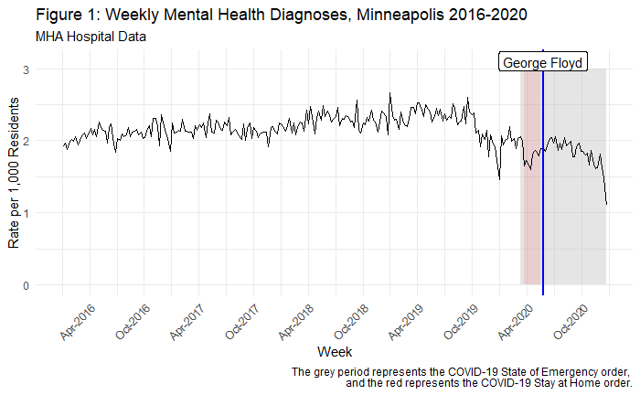

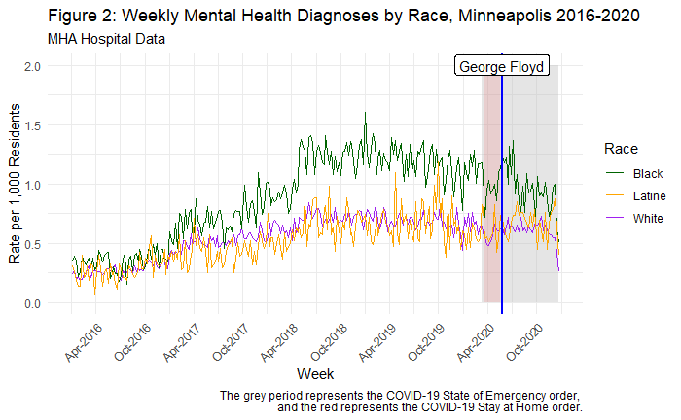

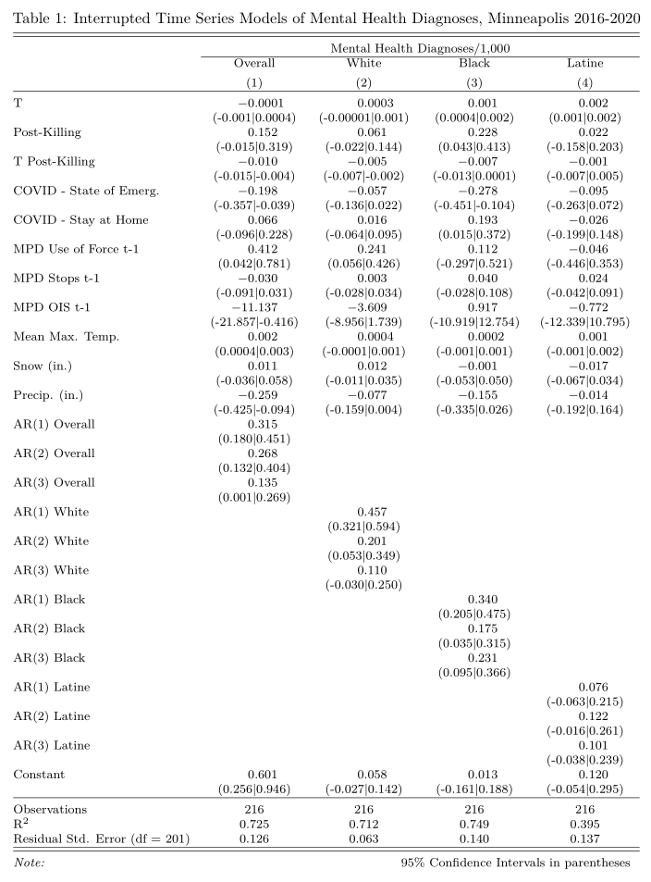

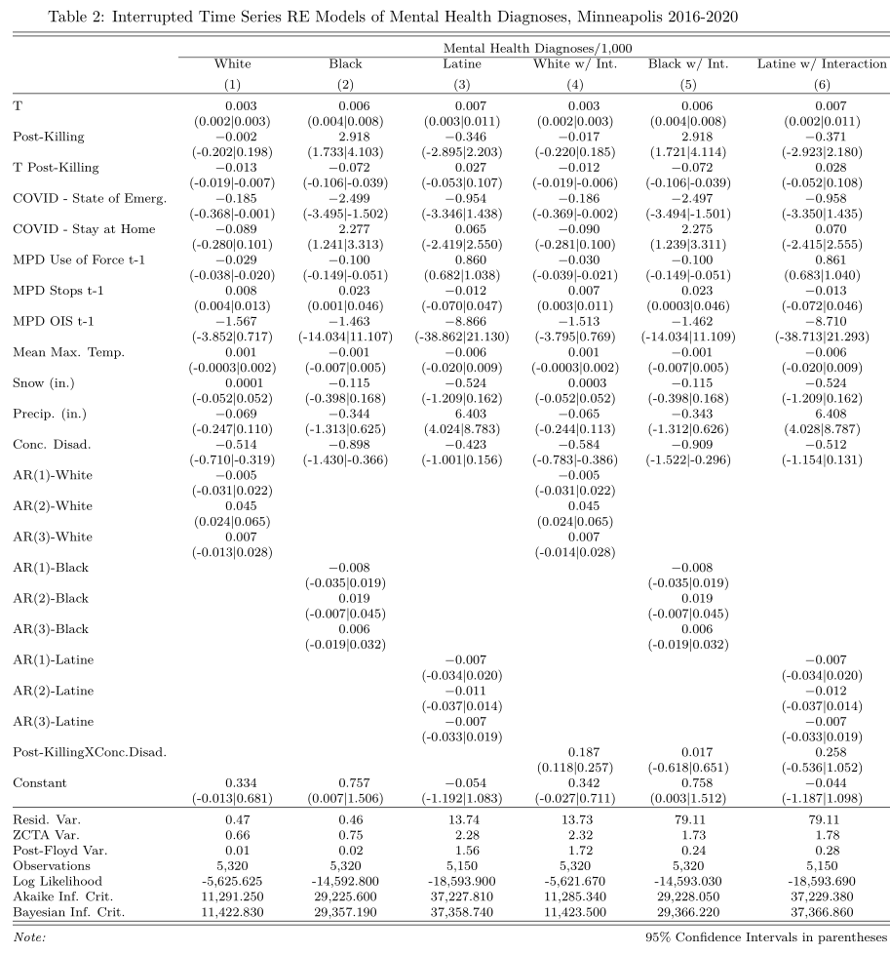

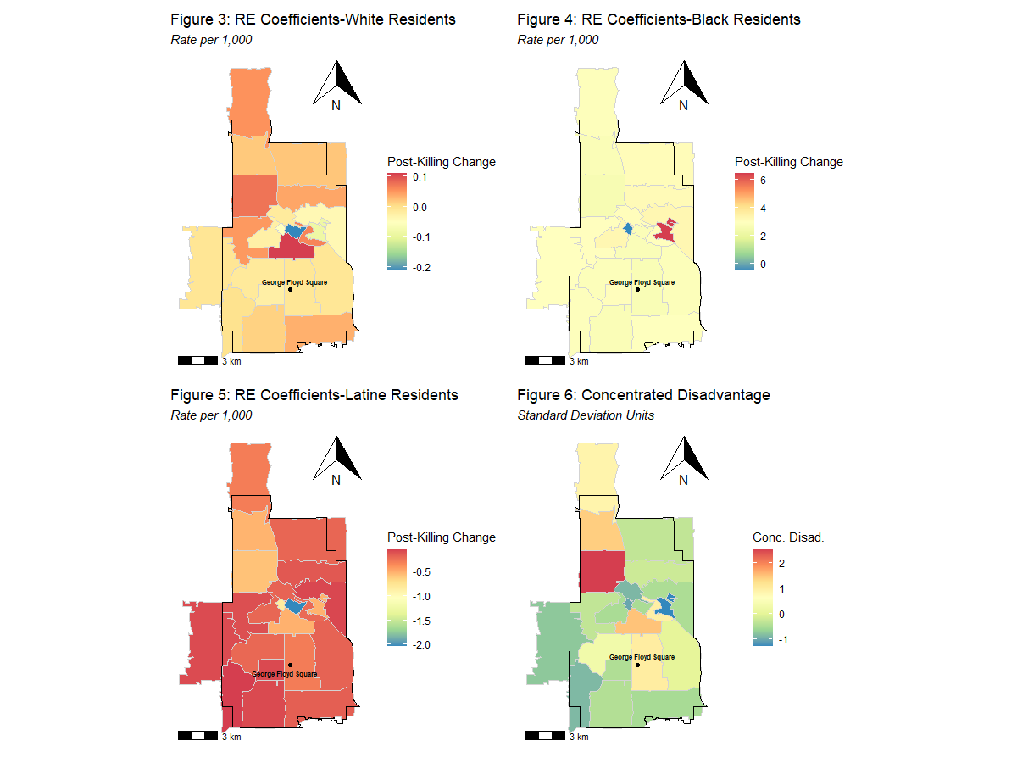

**Appendix**

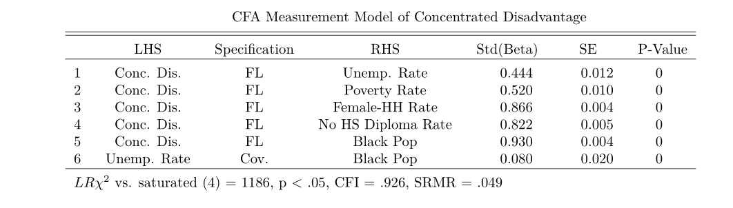

1. We estimated a partial-autocorrelation function (PACF) on the residuals from models without the AR terms, which represent the autocorrelation present at each temporal lag, adjusted for the lags of smaller intervals. The PACF indicated statistically significant autocorrelation up to lag = 3. Therefore we estimate AR(3) interrupted time series models in the final specifications, which account for the autocorrelation structure in the data.
2. Although the Latine post-killing effects tended to be less negative in areas of higher concentrated disadvantage (as depicted in Figure 5), all the estimated ZCTA-specific random coefficients for the Latine post-killing effect were negative in sign.